**FRONT END ENGINEERING-II**

Project Report

Semester-IV(Batch-2022)

**Drag And Drop Using Bootstrap And JavaScript**

**Supervised By: Submitted By:**

Mr. Raveesh Samkaria Shuubham Goyal

2210990845(G13)

**Department of Computer Science and Engineering**

**Chitkara University Institute of Engineering & Technology, Chitkara University, Punjab**

**Abstract**

The project aims to develop a drag-and-drop interface using Bootstrap and JavaScript. The primary objective is to create a user-friendly environment where users can easily manipulate elements by dragging them from one location to another within a web application. The project will leverage the responsive design capabilities of Bootstrap to ensure compatibility across various devices and screen sizes. JavaScript will be utilized to handle the drag-and-drop functionality, allowing users to interact with elements smoothly and intuitively. Key features of the project include customizable drag-and-drop zones, the ability to drag multiple elements simultaneously, and seamless integration with other web components. Overall, the project seeks to enhance user experience and improve the efficiency of web-based applications through intuitive drag-and-drop functionality.

**Table Of Content**

|  |  |  |
| --- | --- | --- |
| **Sr No.** | **Section** | **Page No.** |
| **1.** | Introduction | 4 |
| **2.** | Problem Statement | 5 |
| **3.** | Technical Details | 7 |
| **4.** | File Structure | 8 |
| **5.** | Result | 9 |
| **6.** | References | 22 |

**Introduction**

In today's digital era, user interaction plays a pivotal role in shaping the success of web applications. One of the most intuitive and engaging ways to enhance user interaction is through drag-and-drop functionality. Drag-and-drop interfaces allow users to effortlessly move elements around a web page, creating a dynamic and interactive user experience.

The project at hand aims to harness the power of Bootstrap and JavaScript to develop a robust drag-and-drop interface. By leveraging Bootstrap's responsive design framework, we can ensure that the drag-and-drop functionality seamlessly adapts to various screen sizes and devices, providing a consistent user experience across platforms.

JavaScript will serve as the backbone of our project, enabling us to implement the intricate logic required for drag-and-drop interactions. With JavaScript, we can detect user input, track the movement of draggable elements, and dynamically update the layout of the web page in response to user actions.

Through this project, we aim to empower web developers with the tools and knowledge needed to create immersive and interactive web applications. By mastering drag-and-drop functionality, developers can unlock new possibilities for user engagement and creativity, ultimately enhancing the overall usability and appeal of their applications. Join us on this journey as we explore the exciting world of drag-and-drop interfaces using Bootstrap and JavaScript.

**Problem Statement**

The project aims to address the need for an intuitive and user-friendly drag-and-drop interface in web applications. While traditional web interfaces often rely on manual input or complex interaction patterns, drag-and-drop functionality offers a more intuitive way for users to interact with content. However, implementing a robust drag-and-drop system can be challenging, especially for developers who may not have extensive experience with front-end development.

**Technical Details**

The front-end website for the Analog And Digital Clock was constructed with a minimalist approach, employing only essential technologies to ensure a streamlined user experience. Here are the primary technical details of the project:

* **HTML Structure:** The website's structure was crafted using semantic HTML mark up to enhance accessibility and clarity. Each page was organized with appropriate tags to facilitate straightforward navigation and readability.
* **CSS Styling:** Cascading Style Sheets (CSS) were utilized for styling the website's layout, typography, and color schemes. Custom CSS rules were applied to maintain a consistent visual design across the site while optimizing load times and code simplicity.
* **Responsive Design:** Responsive design principles were implemented to ensure the website's compatibility with various devices and screen sizes. Media queries and flexible layouts were employed to adapt the content and design elements responsively without reliance on frameworks.
* **JavaScript:** JavaScript facilitated interactive features, enhancing user engagement and interactivity on the website. Careful optimization of JavaScript code ensured smooth performance and compatibility across different browsers and devices, elevating the overall user experience.

**File Structure**

* **index.html:** This file serves as the main entry point for the website. It contains the HTML mark-up defining the structure and content of the web pages. Within this file, sections such as the header, navigation bar, main content area, footer, and any additional elements are defined.
* **Style.css:** The CSS file contains the styling rules that dictate the visual presentation of the website. This includes defining colours, fonts, layout properties, and any other stylistic elements. Selectors within this file target specific HTML elements or classes to apply the desired styles.
* **Script.js:** **The script.js file serves as the backbone of the digital analog clock's dynamic functionality, orchestrating its behavior and interactions. Within this file, JavaScript functions are meticulously crafted to enable real-time updates and interactive features essential for the clock's operation. These functions are finely tuned to ensure accurate time display and seamless user interaction.**
* **image folder:** This folder contains all the images used throughout the website. Images may include logos, background images, or any other visual assets required to enhance the design and content presentation. Proper organization within this folder helps maintain the clarity and accessibility of image resources.

**Code:**

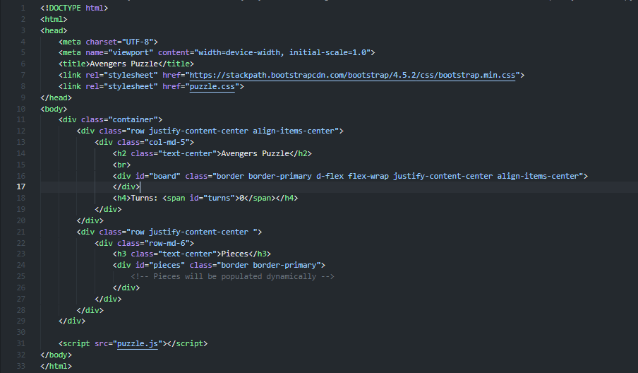

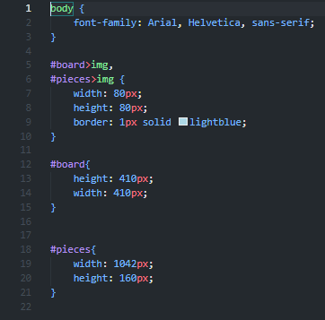

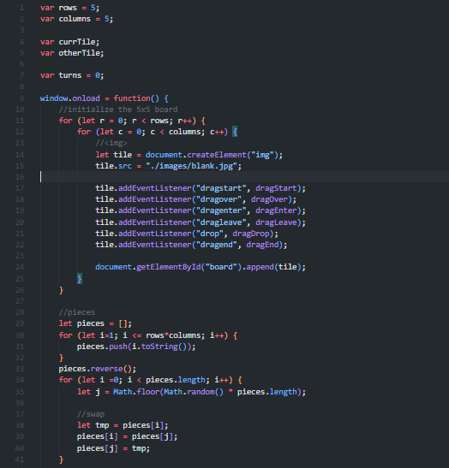

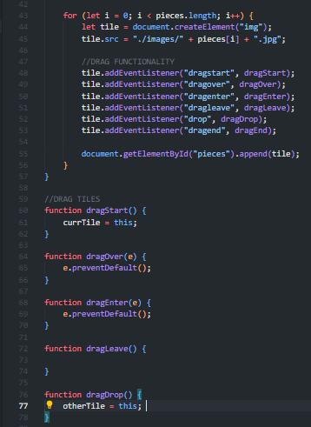

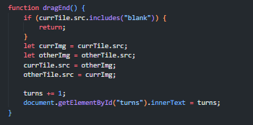

**Results:**

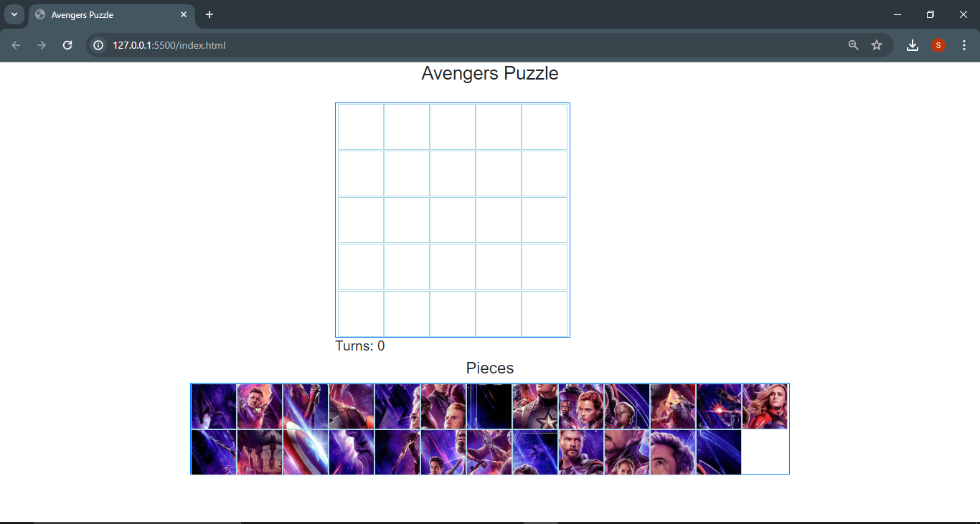

**REFERENCES**

1. https://bootstrap.com
2. [www.w3schools.com](http://www.w3schools.com)
3. https://fonts.google.com